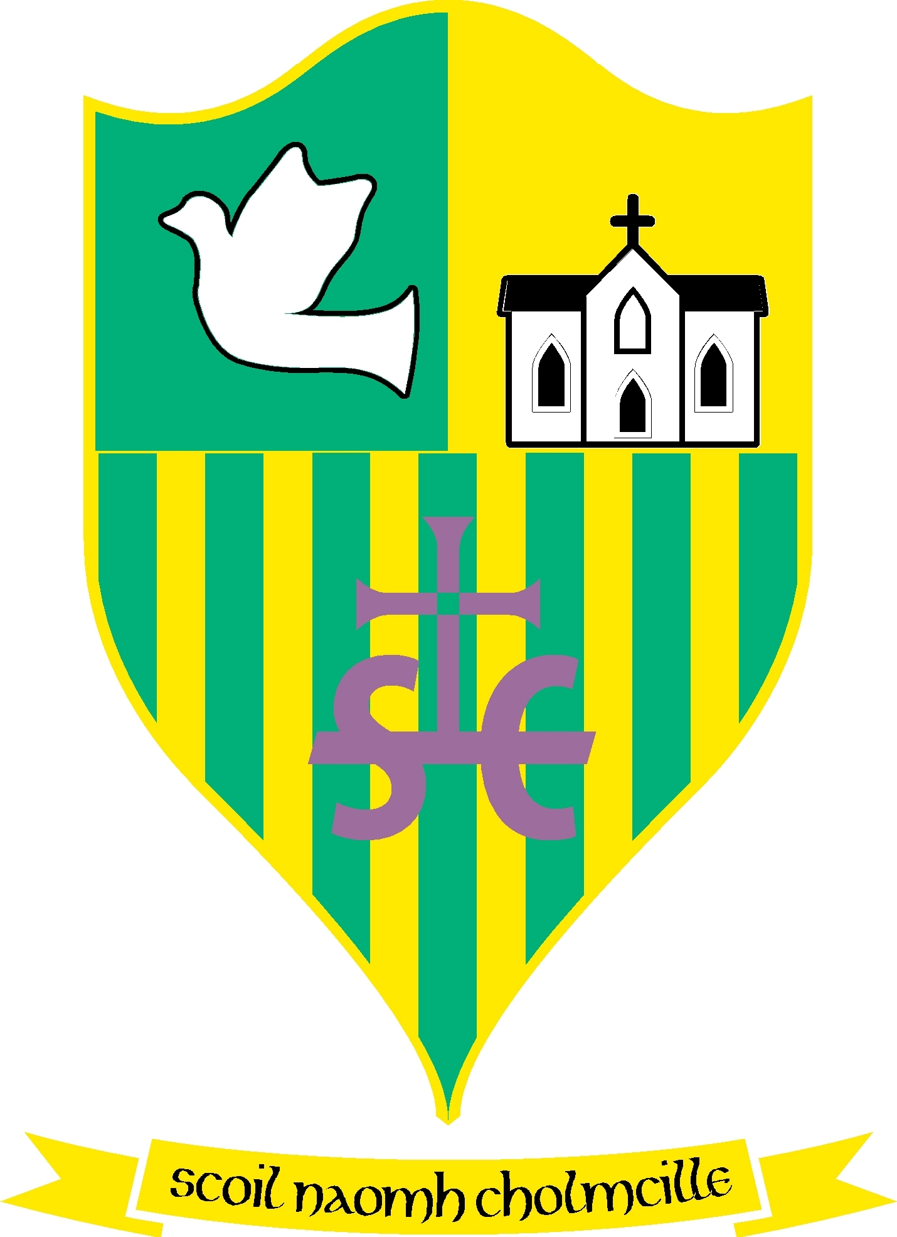
Scoil Naomh Cholmcille

Tullydonnell, Togher, Drogheda, Co. Louth. Ph :041-6852301 Email:st.colmcilles1@gmail.com Roll no 01434O
Dominus illuminatio mea

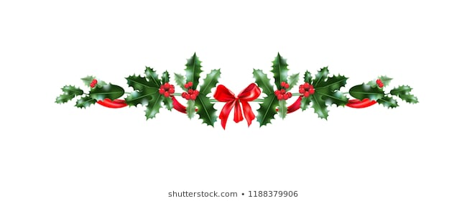

22nd December 2020

Dear Parents/ Guardians,
I would like to wish everyone a very Merry Christmas and every blessing, good health and happiness for 2021. It has been a tough year but please God there are good times ahead. Thank you all so much for the part you have played in keeping our school community safe. Thank you to our wonderful school staff for all their hard work, especially Dolores who is cleaning and sterilising our rooms three times a day. We feel very safe in school! Thanks so much to Seamus Finegan and our Board of Management for their continued support and advice in these unprecedented times. Thanks also to Fiona Mc Geeney and Sinead Sharkey for organising the school raffle and the Parents Association for all the continued hard work in supporting the school. We would like to thank our school chaplain Fr. Daly and Monsignor Jim Carroll for all their kindness and prayers for the staff over the year.
We hope you enjoy our Christmas messages on our website from the pupils and staff of Scoil Naomh Cholmcille, Tullydonnell.
We look forward to seeing everyone in 2021. Keep safe!
Kindest regards,
Anne-Marie Ford.

