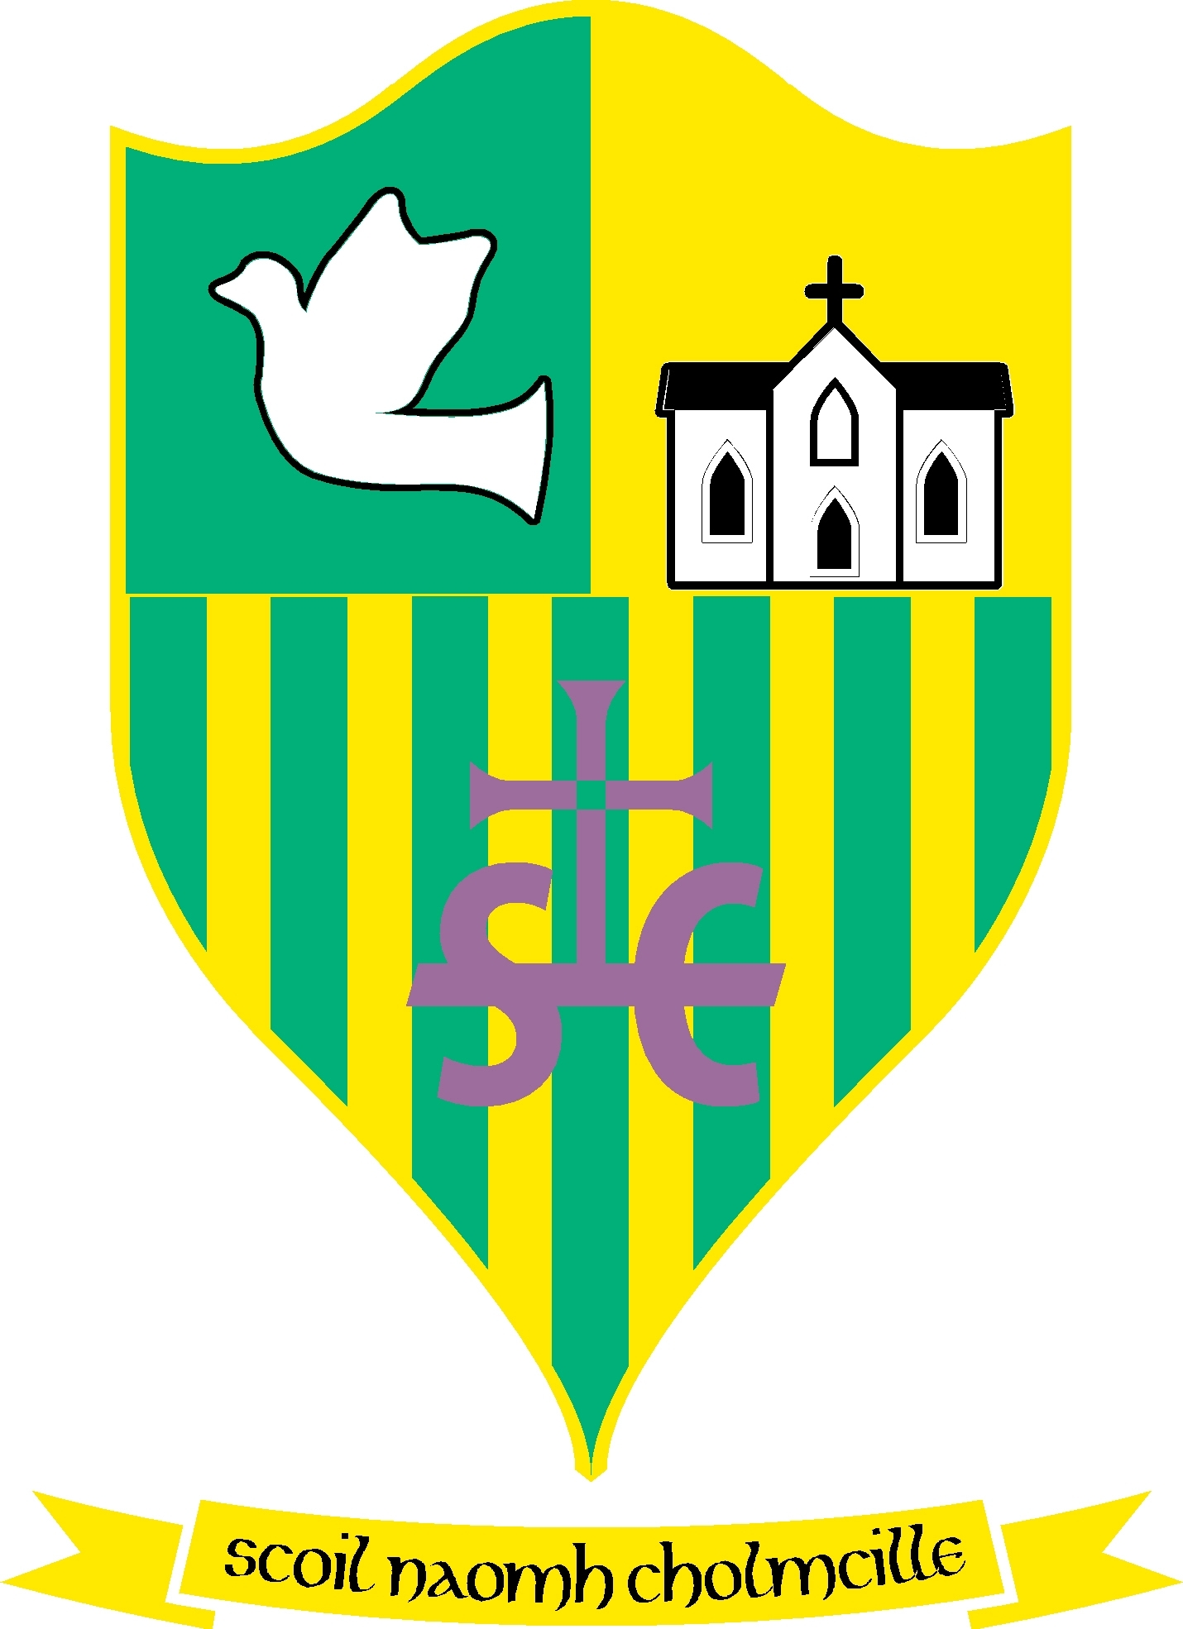
Scoil Naomh Cholmcille

Scoil Naomh Cholmcille

Tullydonnell, Togher, Drogheda, Co. Louth. Ph :041-6852301 Email:st.colmcilles1@gmail.comRoll no 01434O
Dominus illuminatiomea

Dear Parents,
We are really looking forward to welcoming everyone back on Monday 31st August. Please see below for information regarding drop off and pick up times for our pupils.
Drop off in the morning
We are availing of staggered opening times to facilitate social distancing in the morning.
School doors will open from 8:55 am to 9:15am
Children will walk straight to their classroom as soon as they arrive. The procedures and protocols will be in place and Mrs. Ford will be at the main entrance for the first two weeks to ensure that children are familiar with protocol and to direct your child to their new classroom.
It is imperative that children are not dropped at school prior to 8:55 am.

Pick up in the afternoon (Infant Classes)
Junior Infants will be brought to the carpark through the pencil fence passageway at 1:35pm (1:25 pm on Friday)
Senior Infants will be brought to the carpark through the pencil fence passageway at 1:45pm (1:35 pm on Friday)
You may collect your child at this area observing social distancing.
Pick up in the afternoon (1st -6th Class)
1st & 2nd and 3rd Class – 2:35pm (2:25pm on Friday)
4th & 5th Class – 2:45pm (2:35pm on Friday)
6th Class – 2:50 pm (2:40pm on Friday)
All children from the classes above will be brought to the side entrance from the carpark. Please remain in the carpark until you see your child. Children who are going on the bus will be escorted to the bus by a member of staff.

