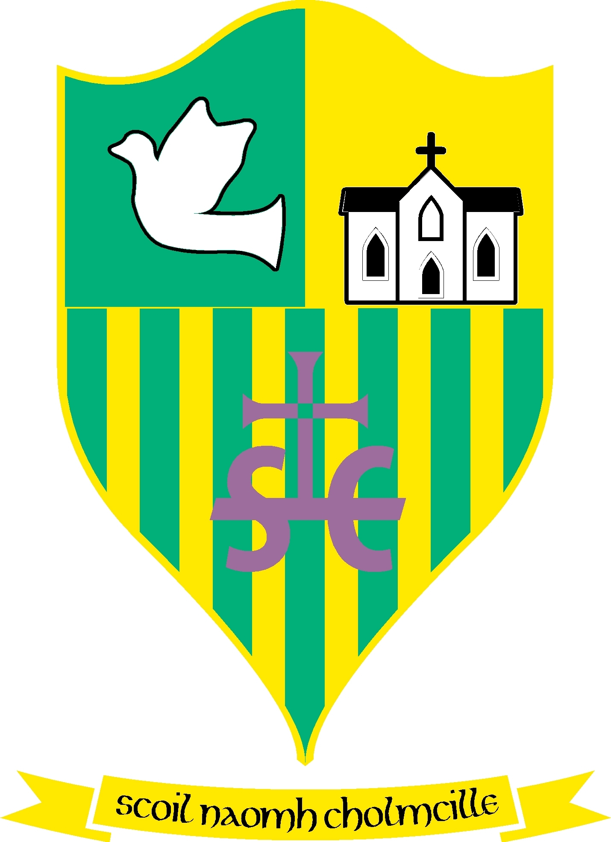
Scoil Naomh Cholmcille

Tullydonnell, Togher, Drogheda, Co. Louth. Ph :041-6852301 Email:st.colmcilles1@gmail.com Roll no 01434O
Dominus illuminatio mea

August 24th 2020

Dear Parents,
Following on from the videos that were posted outlining the policies and protocols for the new academic year this is the ‘Back to School Plan’ for Scoil Naomh Cholmcille, Tullydonnell and is guided by the recommendations as set out in the circular ‘Reopening our schools The Roadmap for the Full Return to School’ 27th July 2020 and Returning to School Curriculum guidance for Primary and Special Schools. This is a synopsis of the road map and how we in Scoil Naomh Cholmcille intend to implement these measures.
Covid Response Policy
This is a generic policy that has been provided by the Department of Education and will be signed by the chairperson of the Board of Management Mr. Seamus Finegan and brought to the attention of staff, pupils, parents and the school community through the school website, www.scoilnaomhcholmcille.ie.
Induction Training
The Principal, Anne-Marie Ford and Chairperson of the Board of Management, Mr Seamus Finegan facilitated a meeting with two Board members Mr. Liam Doran and Mrs. Kathy Maher on Wednesday the 12th of August where school policy and planning was discussed with all staff, our cleaner, secretary, caretaker, teachers, SNAs and bus escorts. Mr Doran and Mrs Maher facilitated clinical guidance on PPE equipment and sanitisation and an evidence based approach to public health guidance in relation to Covid 19.
Procedure for Returning to Work
All staff must complete a Return to Work (RTW) form and should be completed and returned 3 days before returning to work.
Lead Worker Representative
Every school will have a lead worker representative that will work in collaboration with the Principal regarding the implementation of measures to prevent the spread of Covid 19. Mrs Ford the Principal will work with the LWR and the Covid Team to protect against the spread of covid in the school.

Signage
Schools are required to display signage relating to Covid 19 and these will be evident around the school building. These will be evident in Scoil Naomh Cholmcille.
School Layout
Classrooms and other areas of the school will be reconfigured in order to minimise the risk of the introduction and spread of Covid 19. Classrooms will be emptied of everything but the absolute necessities, this will facilitate social distancing and minimise surface areas that may contribute to the introduction or spread of this virus. Please see school videos.
Health and Safety Risk Assessment
A health and safety risk assessment was performed by all staff at the end of June in the school and areas for concern were identified and solutions to the concerns proposed and adopted. This Health and Safety Assessment Document is available for viewing on our school website.
Access to School and Contact Log
Access to the school building will be in line with agreed school procedures.
Arrangements for necessary visitors such as contractors and parents will be restricted to essential purposes and limited to those who have obtained prior approval from the principal. The Department of Education Inspectorate may also need to visit schools and centres for education to support them as appropriate in the implementation of public health advice relating to creating a safe learning and working environment for all.
The prompt identification and isolation of potentially infectious individuals is a crucial step in restricting the spread of the virus and protecting the health and safety of the individuals themselves and other staff, contractors and visitors at the workplace. A detailed sign in/sign out log of those entering the school facilities will be maintained.
The Data Protection Commission has provided guidance on the data protection implications of the return to work protocols. This advice can be found here:
https://www.dataprotection.ie/en/news-media/data-protection-implications-return-work-safely-protocol
Control Measures – To prevent Introduction and Spread of Covid-19 in Schools

- Staff and pupils that have symptoms must not attend school, they should phone their doctor and follow HSE guidance on self-isolation;
- Staff and pupils must not attend school if they have been identified by the HSE as a contact for person with COVID-19 and to follow the HSE advice on restriction of movement;
- Staff and pupils that develop symptoms at school must be brought to the attention of the Principal promptly;
- Staff and pupils will be regularly reminded of the protocol for managing a suspected case of COVID-19 in school (please see below)
Protocol for managing a suspected case of COVID-19 in school

- If the person with the suspected case is a pupil, the parents/guardians will be contacted immediately;
- The person will be isolated and there will be a procedure in place to accompany the individual to the designated isolation area via the isolation route, keeping at least 2m away from the symptomatic person and also making sure that others maintain a distance of at least 2m from the symptomatic person at all times;
- If it is not possible to maintain a distance of 2m a staff member caring for a pupil should wear a face covering or mask. Gloves should not be used as the virus does not pass through skin;
- A mask will be provided for the person presenting with symptoms. He/she should wear the mask if in a common area with other people or while exiting the premises;
- An assessment will be carried out as to whether the individual who is displaying symptoms can immediately be directed to go home/be brought home by parents who will call their doctor and continue self-isolation at home;
- The person presenting with symptoms will be facilitated to remain in isolation if they cannot immediately go home and will be facilitated to call their doctor. The individual should avoid touching people, surfaces and objects. Advice should be given to the person presenting with symptoms to cover their mouth and nose with the disposable tissue provided when they cough or sneeze and put the tissue in the waste bag provided;
- If the person is well enough to go home, it will be arranged for them to be transported home by a family member, as soon as possible and they will be advised to inform their general practitioner by phone of their symptoms. Public transport of any kind should not be used;
- If they are too unwell to go home or advice is required, we will contact 999 or 112 and inform them that the sick person is a Covid-19 suspect;
- An assessment of the incident will be carried out which will form part of determining follow-up actions and recovery;
- Appropriate cleaning of the isolation area and work areas involved will be carried out.
The HSE will inform any staff/parents who have come into close contact with a diagnosed case via the contact tracing process. The HSE will contact all relevant persons where a diagnosis of COVID-19 is made. The instructions of the HSE should be followed and staff and pupil confidentiality is essential at all times.

- Everyone entering the school building needs to perform hand hygiene with a hand sanitiser;
- Visitors to the school during the day should be by prior arrangement and should be received at a specific contact point;
- Physical distancing (of 2m) should be maintained between staff and visitors where possible.

Physical Distancing
Physical Distancing falls into two categories
Increasing separation & Decreasing interaction.
As was discussed on our videos, the children in each class will stay within their ‘Class Bubble’, they will not be allowed to mix with children from other bubbles, even their siblings. Within the Class Bubble the children will be further segregated into ‘Pods’. These Pods will facilitate children sitting together up to 3rd Class, however from 3rd Class upwards the children will be 1m apart within these Pods as per guidelines. There will be no sharing of materials at any time within these Pods. (Please refer to school videos).
Drop Off & Collection
Guidelines: Arrangements for dropping off/collecting pupils should be arranged to encourage physical distancing of 2m where possible. SNC Response: Please see yellow social distancing arrows on the ground. Children will be assigned times for collection at the end of the day. These times will remain the same. This information will be confirmed and communicated at the end of this week 28-08-2020.
Guidelines: Walking/cycling to school should be encouraged as much as possible. SNC Response Where safe to do so and where age appropriate.
Guidelines: Arrangements should be made to maintain a distance of 2m between parents and guardians and between parents and guardians and school staff. SNC Response Please adhere to drop off policy as outlined in video, walking in one direction only through the side entrance, dropping children at the designated drop off point as outlined and following on through to the exit gate. It is up to every individual to avoid at all costs congregation outside or inside school grounds for the safety of all.
Guidelines: Aim of any arrangements is to avoid congregation of people at the school gates where physical distancing may not be respected. SNC Response As above
Guidelines: Staggered drop off/pick up times should be considered where practical and feasible. SNC Response As outlined in the school video teachers will be in their classrooms from 8:55 am and classes will start at 9:15 am to allow adequate drop off time. This will be up for review as the staff assess the efficacy of this approach. Any changes will be communicated to parents.
Guidelines: If schools have additional access points, consideration may be given to whether they can be used to reduce congestion. SNC Response Entry through side gate from carpark and Exit through old main gates at the front of the school.
Guidelines: Consideration may be given to where pupils congregate as they arrive at school. This could include heading straight to their small group designated learning space/classroom. SNC Response All children will walk straight to their classroom, there will be no congregating in the school yard prior to school starting. This too will be reviewed as efficacy is determined.
Collection of Children during the School Day
If an adult has to collect a child during the course of the school day for any reason the following arrangements will apply:
- When the adult arrives at the school, they should either phone the office or use the bell at the front door of the school to alert the office that they have arrived.
- The child will be brought from their classroom, or the isolation station, to the adult by a member of staff.
- Olga our secretary will keep a register of all the children leaving during the school day. These children will leave via the front door.
- No adult should enter the school building, unless invited to do so.

PPE
Class teachers will wear visors in class. Masks are inappropriate where teachers are trying to teach a lesson. There may be exceptions to this rule. Masks will be worn when teachers are in close proximity to children or if a teacher is moving around the classroom. Masks will also be worn in other settings such as in the EIC.
Masks are not recommended for children under the age of 13. There may however again be exceptions to this rule.

Children who should not attend school
If your child is in one of the following categories, they should not attend school –
- Children who have been diagnosed with Covid-19.
- Children who have been in close contact with a person who has been diagnosed with Covid-19.
- Children who have a suspected case of Covid-19 and the outcome of the test is pending.
- Children who have been in contact with a person who has a suspected case of Covid-19 and the outcome of the test is pending.
- Children with underlying health conditions who have been directed by a medical professional not to attend school.
- Children who have returned home after travelling abroad and must self-isolate for a period of 14 days.
- Children who are generally unwell. If your child has a high temperature or has any signs of covid virus do not send them to school.

Impact of a Confirmed Case of Covid-19 in a Class
If the school is notified by HSE that a person in your child’s class has a confirmed case of Covid-19
- The parents of all children in the class will be notified.
- Public health advice will be sought and followed.

Hygiene and Cleaning in school
The Board of Management has taken the hygiene and cleaning in Scoil Naomh Cholmcille very seriously. Our cleaner Dolores has been employed from the beginning of the school day to rotate from class to class to thoroughly clean each classroom.
The children will have three breaks in the day
One 15 minute break, a second 15 minute break and a 10 minute break. In this time while the children and teacher have left the classroom, the room will be completely ventilated. Dolores our cleaner will come in and clean all surface areas, door handles, table tops etc. After this the next class will be released for their break and the same will happen again. This will allow maximum ventilation and cleaning in each room during the day. This is essential to lower the risk of possible infection.
Uniforms/Shoes/Coats
Neither HSE nor the Department of Education have advised against the wearing of uniforms, and therefore uniforms and school tracksuits will be required as normal.

Curriculum Guidance
It takes a lot of thought and consideration to plan for the practicalities of a return to school during this pandemic and adherence to the relevant health and safety requirements is paramount in allowing us to return to school and hopefully stay at school with the minimum of disruption.
There are other areas however that need thoughtful consideration;
- Supporting the wellbeing of learners and school staff.
SNC Response: It has been an anxious time for many, some have lost relatives or known relatives or neighbours who have been ill during this pandemic and we must acknowledge that others we know may fall ill with this virus before this pandemic is over. It is important that this is dealt with correctly without causing undue fear or alarm but with children being mindful of the correct procedures to keep themselves and those around them safe. Our children have had to endure a lot of psychological trauma in the last 6 months. They have missed their grandparents, they have missed their school friends and their teachers and they have depending on their age processed a lot of information from the media about this pandemic. Children will deal with this in their own way. Some will talk about it and ask questions and others will say very little.
We at Scoil Naomh Cholmcille endorse the message from NEPS (National Educational Psychological Service) ‘Slow down to Catch up’. It is vital that we create a secure safe environment for our children. Returning to school is the first sign that some normality is returning for our children and our parents and even though we cannot embrace life in the old normal we must learn to live with the new normal and this will take time. The first thing we must do is create a reassuring environment for our children where they ‘can openly communicate their needs, thoughts and emotions’. We will endeavour to do this and to allow time for children to adjust to school life again.

- Ensuring equity and consistency in curriculum provision and in pupils’ learning experiences.
SNC Response: Due to the diversity of family circumstances we acknowledge that every child’s learning experience while in lockdown was just as diverse. This should not impact or impinge any child’s progress or engagement with the curriculum on return to school as this would be entirely inequitable. We as a staff decided last June after considerable consultation that the time from March 12th until the 25th of June will be revisited in each of the core areas of the curriculum, i.e. English, Maths and Irish. These areas of the curriculum will resume where they left off in March and teachers will cover the content in the month of September.

- Supporting pupils where they are at in their learning and providing them with what they need in order to flourish and be successful.
SNC Response: A base line assessment will be carried out to identify areas that need extra attention. When these curricular areas have been covered by the end of September, the teachers will further assess the children and report home to parents. This year is an anomaly and it may be recommended that your child might benefit from a little extra tuition with a Support teacher. This will be determined by teacher observation, teacher designed tests and in consultation with you the parents. We will support all our students to the very best of our ability.

- Establishing curriculum and instructional priorities and planning accordingly
SNC Response: While the core areas will be a major focus in September, the mandatory areas in SPHE and RSE programme will take priority in September and the early part of the academic year also. Areas that will be addressed;

The importance of personal hygiene and how to wash hands thoroughly, coughing/sneezing according to the medical guidance, and how and when to wear face coverings/masks
• Supporting pupils in managing their feelings, resolving conflicts and coping with uncertainty, as well as new situations brought about by Covid-19 such as loss of a loved one
• Revisiting the Stay Safe Programme or Relationships and Sexuality Education (RSE)
• Allowing pupils adequate time to re-connect with one another and to (re)establish relationships with peers. Co-operative games and the incorporation of drama activities such as role play and improvisation can support this process.
• Providing children with opportunities to talk about and make sense of their experiences.

- Developing and supporting collaboration with parents and agencies, in order to maximise outcomes for all pupils in a fair and equitable way.
While this new academic year will be a little different to what we are used to in Scoil Naomh Cholmcille, one thing remains unchanging we will strive more than ever to do the very best for your children. If you have any concerns please know we are there to listen, to understand and to support your child as best we can. We will report to parents at the end of September / beginning of October and where there is any extra support required we will in line with best practice with the NEPs ‘Continuum of Support’ document ensure that your child can access the curriculum in a fair and equitable way.
This has been a very lengthy document and there is always a balance between giving you as much information to answer any questions and overload of information. If there are any questions that I have not addressed in this document please feel free to contact the school through email and I will endeavour to answer as soon as I can.
Wishing everyone a happy, healthy new academic year.
With kindest regards,
AM Ford &
Board of Management of Scoil Naomh Cholmcille.

