

Well-Being Week

April 27th – May 1st

[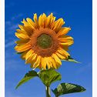](http://en.wikipedia.org/wiki/Helianthus)